**Programming Exercise – (Resolution by Berman Romero)**

1. Source code at: <https://github.com/brleiva/RF_InterviewApp/tree/master/ShapeConsoleApp>

(Visual Studio 2013 solution)

Main files: *ShapeModels.cs & ShapeProgram.cs*

1. Compiled program (.EXE) at: <https://github.com/brleiva/RF_InterviewApp/tree/master/CompiledProgram>

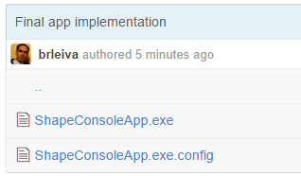

Please download both files: *ShapeConsoleApp.exe & ShapeConsoleApp.exe.config*

1. Start the Console App, then enter **help** command:

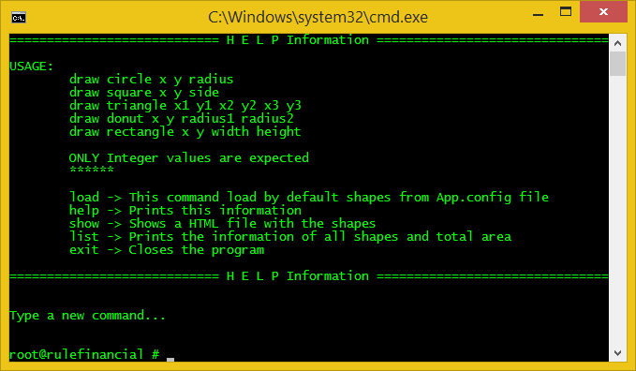

1. Enter some command, for ex: **load** and then **show**
2. When a shape is inside of another shape a yellow message appears:

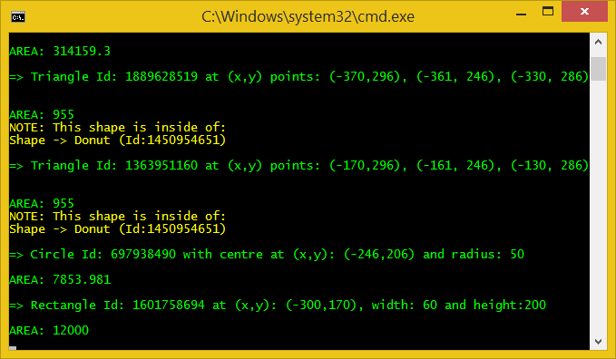

1. HTML example result: (command: **show**)

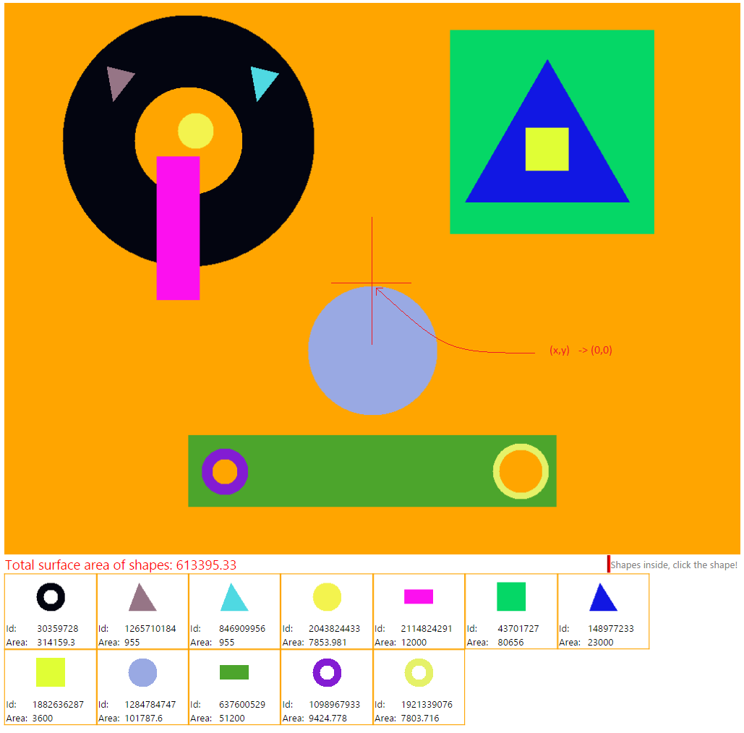

1. Shapes inside: When a shape is inside of another shape you can see one indication like that: (click in the shape to see the shapes inside)

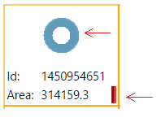

Ex:

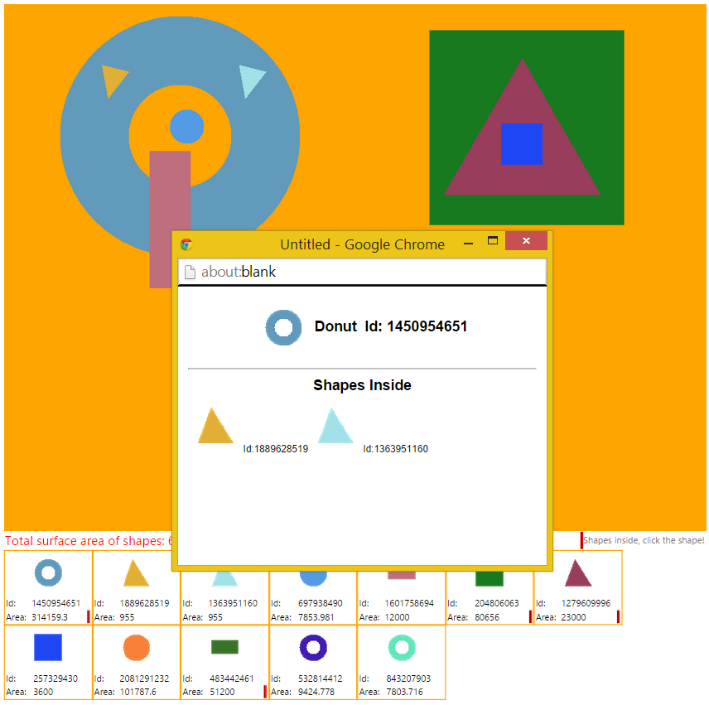

1. Configuration file:

There is two options to set if you want.

1. Default shapes like: (no spaces after comma)

*draw circle -246 206 50,draw triangle -170 296 -161 246 -130 286*

1. Turn off/on algorithm to determine if a shape is inside of another.

